Maitland man's mine death shatters family's dream

By ALISON BRANLEY

Maitland man's mine death shatters family's dream
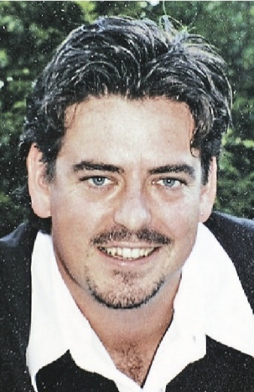
DEVOTED: Daniel Hill got a job in the mines to ensure a more secure future for his young family.
A FATHER of three killed at a mine near Singleton was a devoted dad who was working in the mines to build a better life for his family, his wife said yesterday.Daniel Hill, 34, died while working underground at the Integra Coal mine at Glennies Creek early Saturday morning.It was the Hunter's fifth mining-related death in seven months.Police said Mr Hill was hit in the head by a rotating coal shearer that vibrated loose from a mechanical digger about 2am.He died at the accident scene.Mr Hill's wife Melanie said her husband had sold his restaurant to start work in the mines three years ago to give his family a more secure future.He got the job as a mining technician at Integra about a year ago and mostly worked weekends to have time for his sons during the week.The couple had recently sold their home in Maitland and were about to start building their dream house in Largs.Mrs Hill said Daniel was helping coach their five-year-old son Declan's soccer team and had watched his son's first game last weekend.The couple have another two sons Vincent, 3 and Ronan, 1."He was so proud of the boys," she said."He was a great dad and a fantastic husband."Mr Hill grew up in the Maitland area, he went to school at Maitland Grossmann High and used to own the South of the Border Mexican restaurant in the Maitland CBD.Mrs Hill said Daniel was known among friends and family for his cooking skills."He had a really good sense of humour and he always made people laugh," Mrs Hill said."His kids will miss him and I will miss him. We will always love him."His long-time best friend Brendan Madigan described Mr Hill as a fiercely loyal friend and devoted family man."He was just an awesome, awesome friend," he said."You could ring him whenever and he would be on your doorstep within 10 minutes."Anyone that was a friend of Daniel's was a friend of Daniel's for life."He was just the best husband and father. He just wanted to be with his boys."Mr Hill is also survived by his mother Margaret and older brother Gavin.An accident report will be prepared for the NSW Coroner.

